**Issue: 8|77770400| Input CHARGE_NUMBER : 0310663878 in VOIP_ROUTER_CONTAINER does not exists in CADM.**

Note:-Only one scenario has been covered in this M&P i.e. where site and customer name associated with the router is same else we won’t follow this WA.

**Sample Ticket:** 261358762

**Sample order: 194826404**

Open the order in BVOIP order status tool for the error message.



Take charge number and look in EUAM if it is present in CADM or not

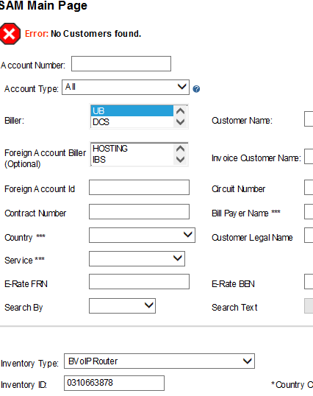

If it is not present then take site id and check order in SPP tool corresponding to site.

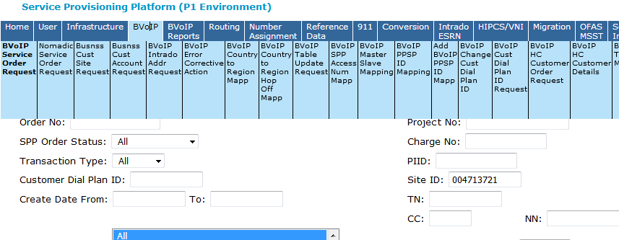

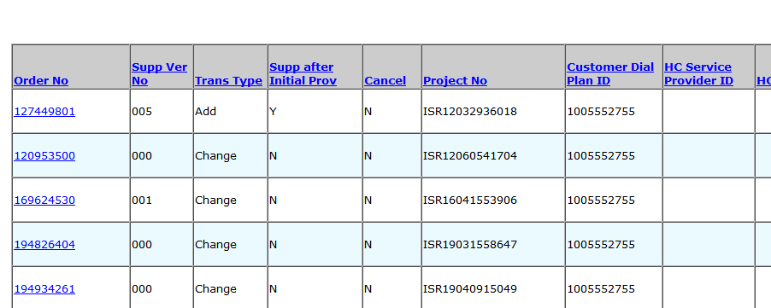

Click on the orders and look for the charge number (if they are same or not).

For example for above order:

for Order No: 169624530 Charge No is 0210707304

for Order No: 194826404 Charge No is 0310663878

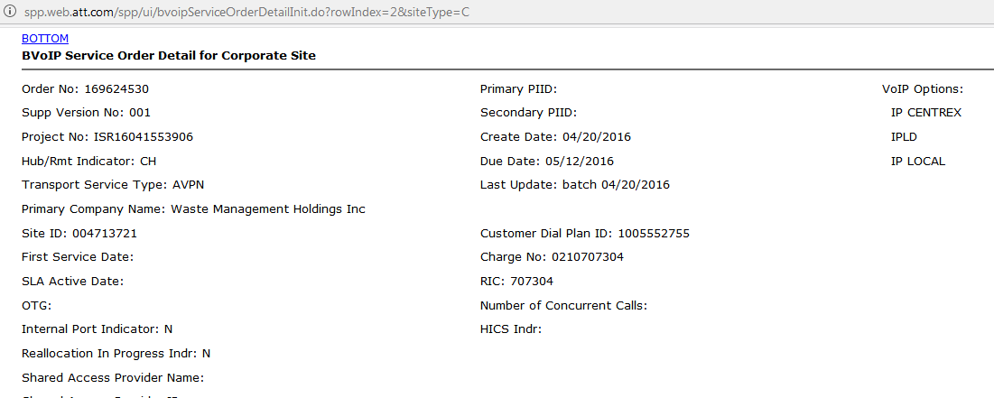

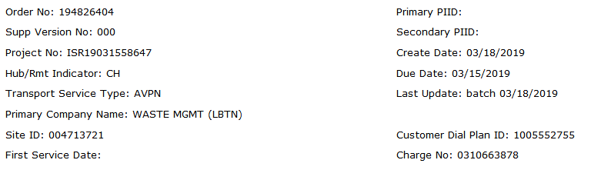

Charge numbers are different that means there is some migration of charge has been done.

Also when the customer is Waste Management there must have some migration done at back end called VDNA migration.

We can check the order number through which that migration has been done and we can check the previous and current router associated with site from SPP tool.

To check that go to SPP tool>BVOIP>BVOIP VDNA Migration Request>put site or charge and we will get order number.

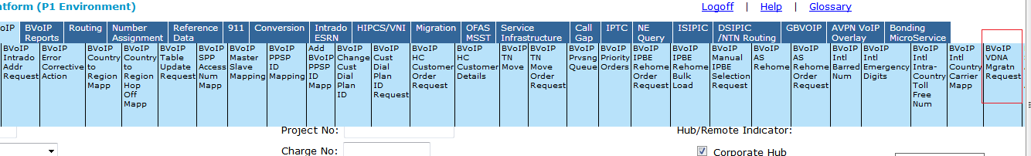

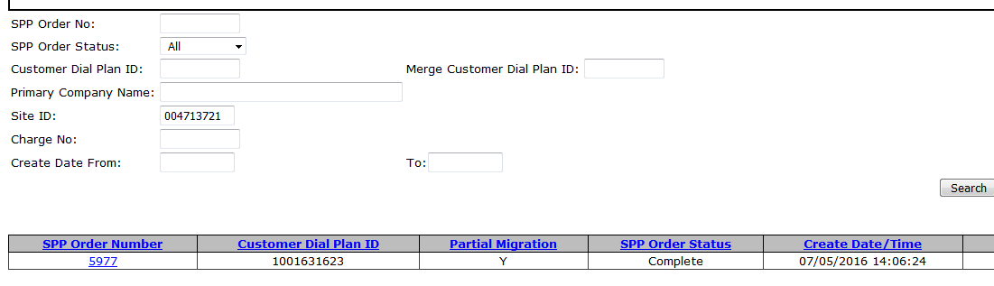

Click on the order number(5977 in this case) and then search for your charge number and we will be able to see old and new charge number for that site



Now check if the old charge number(0210707304) is present in EUAM or not(which is present in this case) and if present then is it with the same customer and with the same site.(if not then we won’t follow this WA)

Customer name can be seen at the top of the EUAM

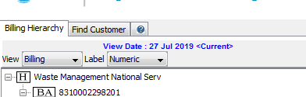

To check site open the greyed out subaccount>click on bvoip under subaccount>click on tax from menu >tax address

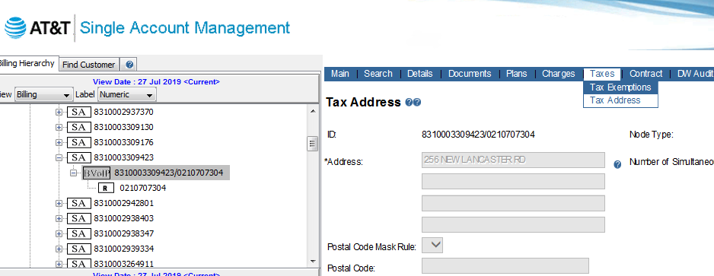

And verify the address (which we can see in SPP tool)

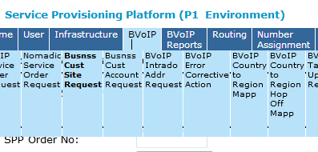

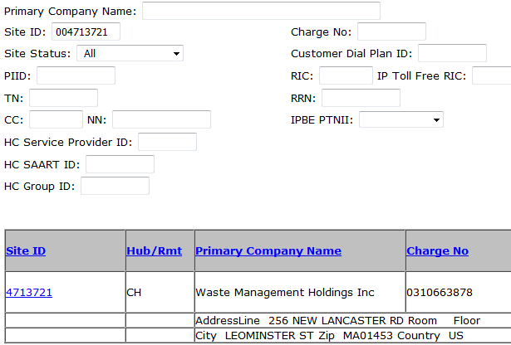

If same address is there in EUAM that means site id is present in EUAM associated with that router.

If all these steps are good then update the old charge number corresponding to order in GIOM DB using below query:

select o.order_name, b.charge_number, l.site_id, b.router_hostname, b.voip_billing_info_id

from iomdbo.iom_order o, iomdbo.location l,iomdbo.voip_info v, iomdbo.voip_billing_info b

where v.iom_order_id=o.iom_order_id

and b.iom_order_id=o.iom_order_id

and v.location_id=l.location_id

and o.order_name in (‘194826404’)

---and site_id in ('004950321')

---and charge_number='0000347106'

--and gw_order_name='SOE1145984'

--and package_name='ISR12070232166'

order by order_name;

--update iomdbo.voip_billing_info set charge_number = ‘0210707304’ where voip_billing_info_id= 11309980;

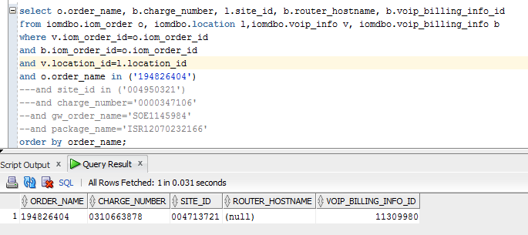

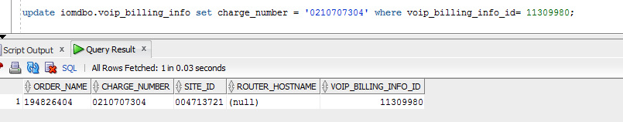

Once the charge number is updated. Complete the GIOM Tier error task in EFMS GUI and billing will be retriggered successfully.



